The magazine of the Dyffryn Clwyd Mission Area
April/May 2021

Cysyllte Dyffryn Clwyd
Some thoughts from Maundy Thursday
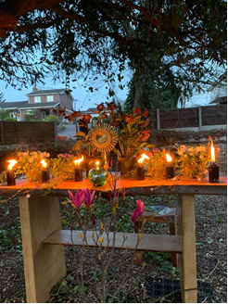
As Tad Huw has reminded us, we cannot experience Easter day if we have not journeyed through the week before.
We were washed and shared the Passover together and then we walked out to the garden of Gethsemane and sat in silence.
I listened, the gentle roar of traffic from the main road gradually stilled, then I could hear the tiny tweetings of birds settling down for the night above my head.
I watched the candles blowing in the breeze, sometimes they stood upright and glowed really brightly but then a gust of wind came and blew them sideways, one by one they went out until only a few were left.
I felt a bit cold but I drew my coat around me and thought about those first disciples, they must have been cold too (it was cold enough for the servants in the temple yard to light a fire and huddle round it later on).
I started to think. Which disciple was I most like; start at the top- John? No possibly not sadly, what about Peter? yes I’m afraid so, a bit more, I’m sure; then what about Judas? Oh surely not! but yes wait a minute, how often have I turned the wrong way, made wrong decisions, let down other people, not followed Jesus faithfully?
I thought about a sermon long ago when the preacher told us to bring our heavy suitcases to the bottom of the cross and leave them there, how wonderful to be able to walk away light! But don’t make the mistake of picking them up again!
Annual Easter Vestry Meeting
29th April, 7pm on Zoom
The Easter season is one full of hope as we spend 50 days celebrating that amazing morning when the world was changed in an empty tomb.
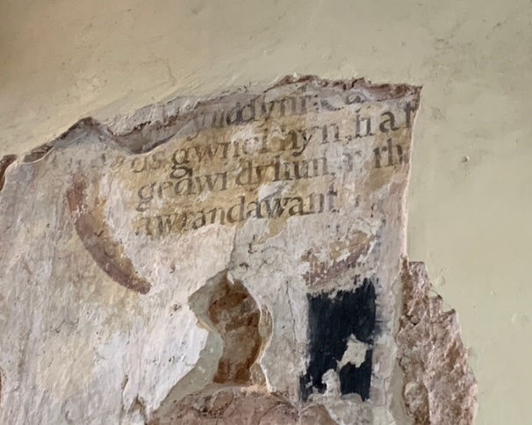
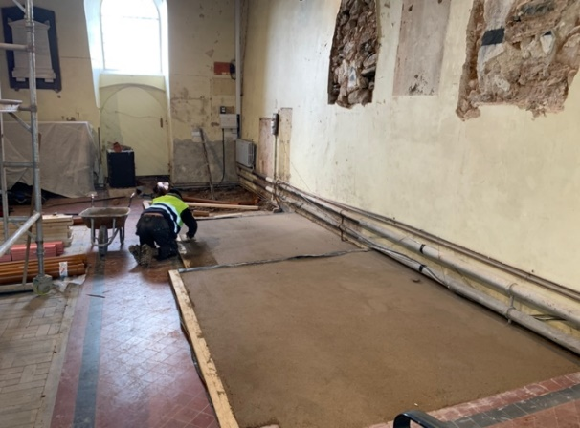
As this season rolls on we look more and more at how the resurrection, renewal and rebirth play out in our personal lives and in the life of the church. This year it seems more real as we see the unlocking of our communities from pandemic restrictions going hand in hand with the resurrection narratives. It is great to atlast be able to say all of our churches are open for regular worship, and whilst we must still follow certain procedures to keep everyone safe it is great to see more and more of you once more coming to worship in person.
While society looks at what has changed as they re-open things, we are also looking at our churches to see what has changed over these last 12 months. This idea of us having taken the time of lockdowns to reavaluate what is important to us in our churches and how we take with us the best of the past whilst looking to the new is most apparent in Llangynhafal church. This time of lockdowns has been used to renew the fabric of the church, first in repairing and now in re-ordering. As part of this renewal we have uncovered hidden treasures of the past (some wall paintings which were hidden behind memorials and plaster), we have dug down to our roots (60 metres down to be precise to tap into the holy waters that flow beneath the church to the nearby Holy Well of St Cynhafal) and are building for the future (toilets, kitchen and comfortable seats!). But just as the fabric of the building is being renewed for the mission of the future, so we need to look at our spiritual lives as a mission area and seek to renew and refocus our energies on mission.
As part of this we have, with the Diocese undertaken a review process. This process looked at our mission area in it’s whole, our buildings and what state they are in, our finances as a whole, and our 10 year attendance trends. We then visited every church in the mission area, meeting with church wardens and talking about where we see God at work within the church walls and outside them. Working with the Diocese we have then come up with a report and some key recommendations for us to implement.
In preparation for this document we have spent Lent with Church Wardens, the Shared Ministry Team and other key individuals across our mission area working through a book called Divine Renovations which encourages us to move out thinking from Maintenance to Mission, to re-capture our primary purpose as those who were commanded by the risen Christ to go and make disciples.
The Review document and it’s recommendations will be sent out to everyone in the mission area ahead of our Easter Vestry meeting. The Easter Vestry meeting, our annual meeting which is open to all members of our churches, will be held on the 29th of April at 7pm. As this meeting is an open meeting and can include all of the 180 regular worshiping members of Dyffryn Clwyd, it will have to be held on Zoom this year. A link will be sent around with the agenda the review documents. Because of the difficulty of online meetings, it will not be possible to have in-depth discussions on the Review, but I will be asking for questions on it to be sent to me in advance.
Following the Easter Vestry we will be setting dates in May for each church to have a full congregational meeting for the sole purpose of discussing the Review, what it will mean at a local level and feeding these discussions back in to a Mission Area wide MAP (Mission Action Plan) which will then be formulated through June and put to the MAC (Mission Area Conference) at the end of June. The rest of the year will then be devoted to putting our plans into action.
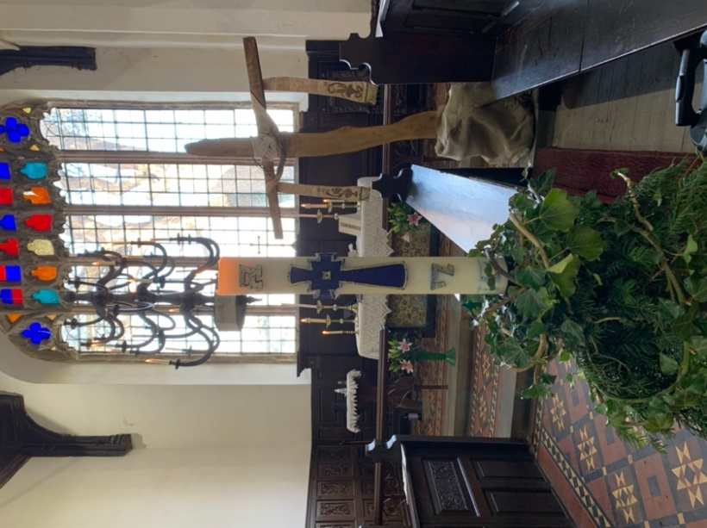
Whenever the ‘future’ of the chuch is discussed, this can make us aprehensive thinking as it is so often associated with closure, but that is not the purpose here. The purpose is to acknowledge that we can not continue to do the same things and expect different results. 10 years ago our Governing Body declared openly what had been being said for years, “The Church in Wales cannot go on doing the same things in the same way; some things need to change and we are open to – and indeed encourage – that possibility”.
We have seen some changes since then with the advent of Mission Areas and legal obligations have forced changes to some of our structures, especially in finance and for our treasurers, but largely in our individual churches we have continued much as we always have. We pray in our churches for growth, growth in faith and in numbers, but to grow is to change. We are in a good place as Dyffryn Clwyd, we have people, we have money, we have beautiful churches, but above all we have faith and prayer. Change is not always easy and it does come at a cost, but with the faith of the Risen Christ we can have confidence in our churches to follow our Lord’s command to go and make disciples and not only survive but thrive.
Alleluia! Christ is risen!
He is risen indeed! Alleluia!
Tad Huw
Resurrection Power…

We start this month celebrating Easter and I have found myself drawn to these words of St. Paul:
I want to know Christ and the power of his resurrection and the sharing of his sufferings by becoming like him in his death, if somehow I may attain the resurrection from the dead.[Philippians 3:10-11]
Do you have anyone of whom you can say that you really know them? There are a lot of people that I count as friends and I know a lot about them. But do you really know them in the sense of understanding what makes them “tick”? What choices they will make? How faithful they are? How they will respond in certain situations? Where their loyalties lie, and to what extreme?
Do you know them by facts or by experience? Is it something they have told you, or something you KNOW because you have lived it and felt it?
Really knowing something or someone is more than an accumulation of facts. Really knowing involves the heart more than the head.
In The Prayer Course we have been reminded that Christianity is a relationship with a living Saviour, a Saviour we can know, a Saviour who infuses our life and empowers us both as individuals and as His Church; a Saviour who transforms us, heart and mind, into his likeness. Knowing Christ is much more than knowing facts about God but about knowing Christ through a deep, personal relationship with Him. Like all relationships this involves spending time in his company, being with Him, listening to Him, learning to trust Him and His power…
This is reflected in the second part of Paul's desire: "to know . . . the power of his resurrection." Note that Paul does not ask God for more power. Instead, he asks God that he might know the resurrection power he already has.
The Good News of Easter is that God’s resurrection power is already in us His Church!

Stuart

Editor’s Note
Firstly a big thank you to all those who have contributed articles and pictures to the magazine. If you haven’t yet contributed please do; it doesn’t have to be earth shattering news, it is uplifting just to know that other churches are worshipping and praying alongside us.
You may notice that this edition is labelled April/May which means March has been omitted. There has been some uncertainty about deadlines, partly due to COVID and also because initially it was not certain how often the magazine would be published. It now seems to have settled at every other month and I am proposing that the deadline for copy should be the tenth of the month. This means that the deadline for copy for the next edition (June/July) will be 10th June. I will include the deadline in all future editions. Apologies if I have left out input because it was now post-dated.
A few technical points. The text of the magazine is in 10 point Arial font. I hope everyone finds this legible. If you use something else don’t worry as I can convert.
The best format for editing pictures is JPEG. Nearly all digital cameras use this so it shouldn’t be a problem. If you send something else (PNG) I can convert.
Originally I proposed that individual churches should print their own copies. I don’t know how far that is working out. If anyone wants help doing this please ask.
Paul Chamberlain

From Esther
Building on our connection with Home-Start, Dyffryn Clwyd is working with Denbigh Mission Area to provide gifts for families who may be struggling. Following on from the success of our Christmas hampers, we will be providing Easter gift boxes with many treats inside. These will include a Real Easter Egg (containing a booklet about the good news of Jesus); a handmade Easter card; Easter sweets; Body Shop toiletries; baking kits, sunflower seeds, an outdoor treasure hunt and stay safe kits including face masks and hand sanitiser. We hope to show Jesus’ love to everyone involved in this project. Many thanks to everyone who has supported these hampers and boxes so far! If you would like to help in any way, please contact our Youth & Children’s Chaplain Esther at esther.andrews.ycc@hotmail.com.

ST. MEUGAN’S LLANRHYDD
Good Friday – Stations of the Cross -12 noon
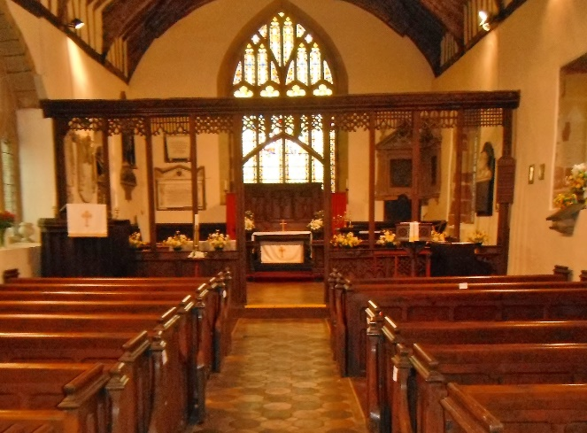
This was our first visit to St. Meugans since Christmas Day. It was very well attended with 15 people present. Rev. Stuart and John Griffith officiated together with David Smart. It was so touching at the end of service as I watched Stuart walk out of Church and up the path – carrying the cross on his shoulder on his journey to the other two Churches. Our thanks to everyone who attended.
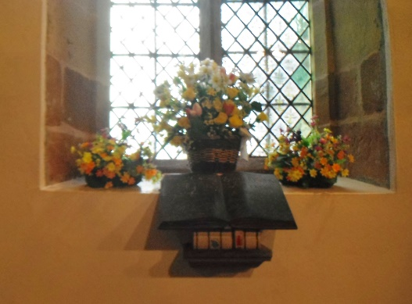
Easter Sunday –“ Alleluia he is risen” – 9am – bi-lingual service
This again was very well attended with 17 people present. Rev Stuart welcomed and thanked everyone for their contribution for cleaning and decorating the Church. David Smart again officiated with organ music and the lessons in Welsh and English were read by Haf Roberts. We all joined together in wishing John Griffith a very happy birthday.
Thank you Stuart on behalf of us all
Haf
Church Warden

Of Zoom and other things
It’s been a long, difficult and different year and now hopefully we’re beginning to emerge. We’ll have to wait and see how things eventually settle down, whether it’ll be a new normal or whether we’ll get back to the old normal.
For me there have been silver linings amongst the gloom of Covid clouds.
I have really enjoyed the online services. I’ve been taken to new places such as Old St Peters, which I’ve now got on my list of places to visit in person. We’ve seen how resourceful and determined our clergy can be producing daily services all through both lockdowns, not to mention outdoor altars and crosses. I’ve enjoyed the sometime breezy outdoor services and been able to concentrate more than if I were there in person wondering if my order of service would blow away. I find more stillness watching and participating in the online service, I’m not sure why, maybe it’s because there’s no rushing about and making sure the church is prepared and no one apart from the dog can hear me sing.
The Lent and beyond, courses (I thought they were 6 weeks but they aren’t they’re 8!) on Zoom have been extremely effective. I particularly enjoyed the breakout rooms, where groups of up to 5 meet privately to discuss questions posed by the leader. Not having to go out in the dark is a bonus, and the coffee is better.
I realise that technology is discriminatory, some people don’t have the internet, others may not possess the technical skills to access Zoom, others dislike social media and decline to use Facebook and some have extremely ropey internet connections where you see that spinning disc far more than the service and Zoom keeps dropping out. Where I live we have been promised fibre soon, however Openreach’s definition of soon is somewhat elastic. Of course for the housebound, those with mobility or transport problems technology can be liberating, enabling them to be involved on an equal footing with the rest of us. Geography becomes irrelevant; we’ve had participants from around the UK in the Prayer course
Personally I would be very happy to continue with some online courses, groups and meetings. I would be interested to hear what other people think.
Sue Hanahoe St Garmons

St Peters Church Llanbedr Dyffryn Clwyd.
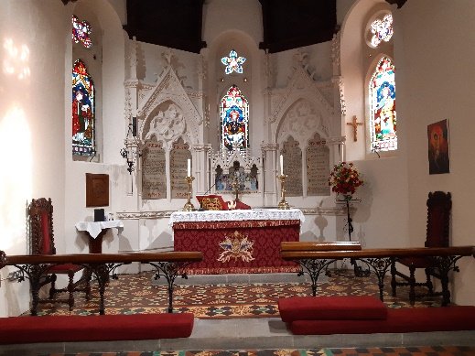
In 1860 John Jesse the new owner of Llanbedr hall recorded in his diary that graves were shallow and he had witnessed human bones being exhumed during burials. He subsequently agreed to build a new church for the village.
Inside the new church which is the current St Peters there is a plaque inside the church recording the erection of the church in 1863 under the patronage of John Jesse. The church was consecrated in September 1864. There are other members of the Jesse family buried in the church yard.
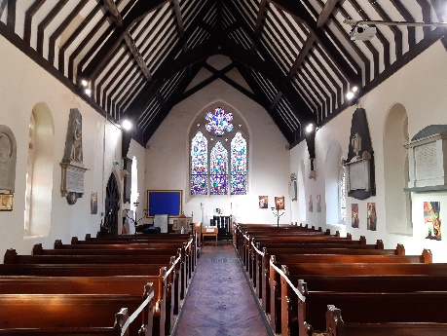
The church is a Grade 2* listed building, the two pairs of gate piers with single gates flanking a pair of central double gates are listed as a fine set of piers and gates which are an internally-designed part of the setting of the church.
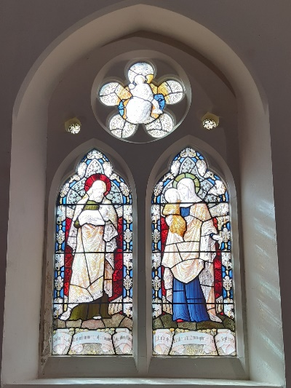
Also listed is a monument in the church yard in the form of an early English-style tower with crocketed finials and tall spire. The plinth is stepped in three tiers. The main face of the lower tower section was built with a roundel within its niche containing a small commemorative limestone bust of Jon Lloyd of the Middle Temple KC.d.1806. Inside the church there are many monument and plaques of the Lloyd family of Berth and Rhagatt including a classical monument to Ursula Lloyd removed from the old St Peters church and reset here around 1863 also removed from the old church a large grey marble benefactor’s board on a black marble background dated 1787.Many of the stained glass windows are dedicated to the Lloyd Family.
The window at the back of the church is stained and painted glass in early C13 style and shows scenes from the passion. Below the window there is a carved stone which was found in 1981 in the old St Peters churchyard and is part of a gravestone very similar in design and workmanship to one at the Vale Crucis Abbey Llangollen which is dated to the early 14th century.
When the lock down is over and the church is open come along and see these windows and monuments and visit the church yard with the outside altar area and a garden being created for Easter.
Gwenda Williams Llanbedr Church

The Ruthin Town Churches mark Lent, Holy Week & Easter:
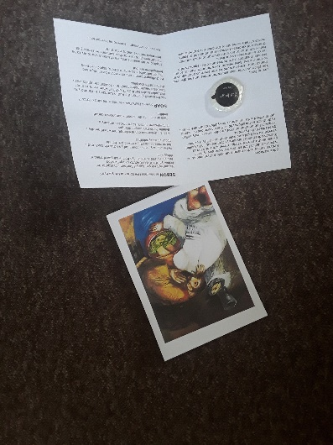
Who would have thought when we were writing an article for the Christmas edition that we would still be living under restrictions during Lent!!
GOODBYE AND HELLO
Well, lots has been happening, we said Goodbye to Dylan who has moved to become a Priest in Charge in Wrexham Mission Area, rooted in the church communities of Esclusham and Poyser Street.
Despite being in ‘lockdown’ we were able to celebrate with him via zoom. We were overwhelmed by the number of messages and donations we received from our Church family and the wider community for Dylan’s farewell. We were able to make him a ‘scrap book’ of messages which were a testament to the impact he had on the locality and we hope he will cherish it for years to come.
Whilst saying “Goodbye!” to Dylan we also said “Hello!” to Dan Morgan who is an ordinand in training. Dan hopes to be with us until June 2022 and we are enjoying having him as part of the St. Peter’s Church family and looking forward to contributing towards his development as he continues the next stage of formational training.
We also pass on our CONGRATULATIONS to Elaine and Debbie who have been accepted for their ongoing training.
Our buildings have been closed since January and we are grateful for the opportunity to continue to worship via the daily online services that the Clergy have worked tirelessly to ‘produce’ using their new-found tech skills!! People have shared with me that it has helped them to stay connected and maintain routine in their lives during this difficult time. We have noticed that lots of people who do not habitually come to Church have been tuning in and the feedback has been positive. The weekly, Sunday post-service virtual coffee ‘zooms’ have been a great success with the opportunity to meet with members of congregations from across the Mission Area, a wonderfully reminder of how we are linked together in Christ. As the weeks have progressed there has been a real sense of ‘gelling and understanding’ over our shared faith and experiences. Alongside of this there has been lots of pastoral outreach work by the Church family which has helped fill the void for many people of restricted family contact because of the ongoing travel restrictions.
In St Peter’s Ruthin and St. Mwrog’s, Llanfwrog, we were excited to open our Church doors again for Mothering Sunday, following a Spring Clean.
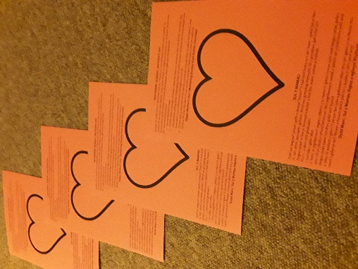
Building upon the engagement with our virtual worship, we have attempted to reach out and engage with the wider town community.
In the week leading up to Mothering Sunday we delivered red hearts through the townspeople’s letterboxes inviting them to write a message to someone who had ‘mothered’ them and place it in their window. (We have a newfound respect for our posties….some of those letter boxes at Glasdir have very strong springs!! I was relieved to find I still had 10 fingers left!!).
During the streamed Service, members of the congregation were invited to share what ‘mothering’ meant to them, also to write a message on a red heart which we then displayed as a collage for all to share on the notice board outside.
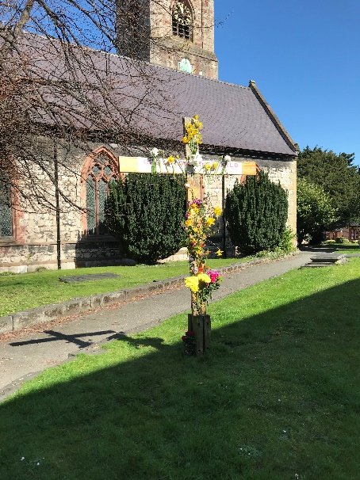
Once again for Maundy Thursday we donned our walking boots and set off delivering leaflets with soap attached, challenging people to wash the feet of someone they cared for just as Jesus washed the feet of his disciples on this day. If that was a “step too far” people were encouraged to consider what act of humble service they would dare to do, what sign of “foolish extravagance” they would demonstrate on what was also April Fool’s Day!
On Holy Saturday, prior to our MA Easter Vigil, we dressed the cross outside of St Peter’s with a coat of Chicken wire and invited townspeople to transform the cross with fresh flowers as a symbol of new life for Easter Sunday.
Easter Day itself saw QR codes were placed on posters around the town which told those scanning it the story of Easter and much fun was had by children and families hunting chocolate eggs that Stuart (aka Easter bunny) had hidden around the town.
Meeting together online and for ‘walky talky’s’ (when the rules allowed) has given us the opportunity to consider future fundraising opportunities. This is especially pertinent as St Peter’s Ruthin must find an extra £8000 to our Mission Area share. So……any fundraising ideas would be greatly appreciated!!
Essential work on the trees is finally to commence in St Peter’s Churchyard at a cost of £3000. We are hopeful that a Community Working group will be established regarding the cleaning up of the Churchyard and help to make it into a ‘green space’ which will assist in our aspirations to achieve an Eco Church bronze award.
Please let us know if you wish to be involved.
Once again, thank you to all those who have contributed so generously with their time, treasure and talents to make our missional ventures – in person and online – a positive opportunity to celebrate the resurrection of Christ.
Jayne Greening.

Contacts
Tad Huw Bryant Llanbedr DC 01824 705286
Revd. Stuart Evans Ruthin 01824 702 068
Revd. Richard Carter Llanfair DC 01824 703 867
Dyffryn Clwyd Mission Area Office
Contact details and opening times
An answer phone message can be left, outside office hours.
Email: admin@dyffrynclwyd.co.uk
Tuesday 9.00 am – 4.30 pm
Thursday 9.00 am – 4.30 pm
TEL: 01824 707 820
Because of lockdown restrictions please telephone
the office before attending.

Churchwardens

Llanarmon | 01824 780 751
Llanbedr | 01824 703 788
Llangynhafal | 01824 790 726
Llanynys | 01824 790 593
Llanychan | 01824 702 152
St Peter’s | 01824 702 392
St Mwrog | 01824 704 643
St Meugan | 01824 703 505
Clocaenog | 01824 750 653
Cyffylliog | 01824 710 249
Efenechtyd | 01824 705 790
Llanelidan | 01824 750 288
Llanfair | 01824 702 594

