Ardal Cenhadaeth DYFFRYN CLWYD Mission Area
Eglwysi Tref RHUTHUN Town Churches
invite you to join us for a summer afternoon reading and discussing the book “The Recovery of Love” by Naomi Starkey.
WEDNESDAYS 14:00 – 15:30
£3:50 for hot drink, cake and discussion at Pen y Bryn café,
Upper Clwyd Street, Ruthin.
[Opposite “Fat Boar on the Hill”]
From Wednesday 20th July until Wednesday 31st August.
EVERYONE WELCOME – people of faith or no faith!
Come with an open mind, an open heart and a willingness to listen and learn from one another…
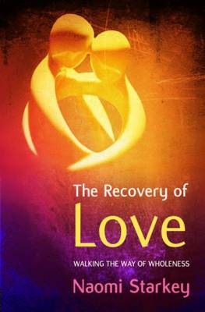
“All too often the world of faith exists in a separate compartment from where our real living has to happen. This fresh and honest book seeks to bring the two together in an authentic relationship, not by giving answers but by following the questions. Through story-telling, gentle and tough by turns, the invitation is to awaken to a presence, often hidden, that waits to meet us in the midst of daily living….” David Runcorn.
Books cost £7 and we want you to have a copy in advance
so please let Stuart know that you’re coming by Sunday 3rd July
– cymrostu@gmail.com / 01824 702068

