St. Michael and All Angels
Harvest Thanksgiving
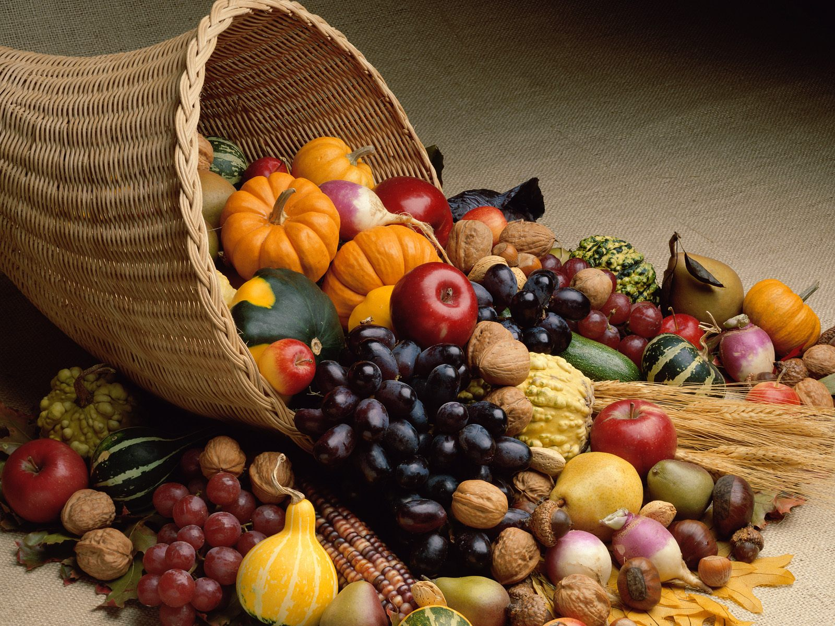
Harvest Thanksgiving Service at Efenechtyd Church at 12 noon
Saturday, 22nd Oct. 2022
Soup and Harvest bread

Everyone welcome! / Croeso i bawb!
Donations of dry or tinned food for Ruthin Food Bank, please!

