Gwylmabsant

St. Michael and All Angels
Efenechtyd

Saturday, September 24th 2022 - 2pm start

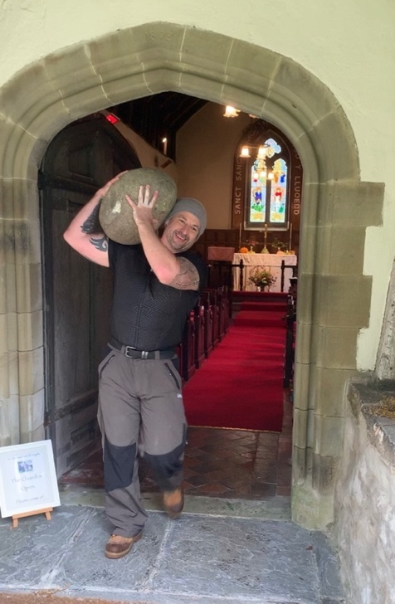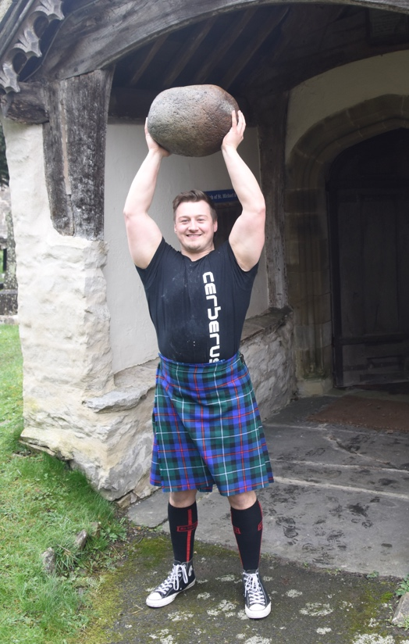

- Short service to celebrate our Patron Saint’s Day
They will be demonstrating how to throw such a heavy stone (101 lbs) and competing against each other!

Everyone is welcome to see if you can beat them!

They will be raising money for the worthwhile charity, The Wallich – Wales’s leading charity for homelessness.
Tea and Cake!
- Come and meet this years’ guest stone throwers
- Tea and cake
- Take up the challenge and throw the stone - we have stones of all weights and sizes for all!

- Collection in aid of The Wallich (homelessness charity)

